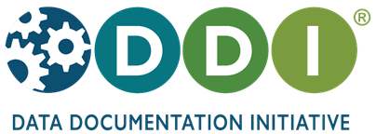

an international open standard for describing the research data lifecycle

www.ddialliance.org

DDI supports the comprehensive description of survey and social science data for discovery, analysis, and sharing. Because DDI is a structured specification, it makes research data machine-actionable and interoperable.

DDI can be used to both document existing data and drive systems to capture new data. DDI focuses on metadata reuse; “enter once, use often” means you can reuse metadata over the course of the data life cycle to avoid costly duplication of effort.

DDI is a free and open standard. DDI ensures that your data are:
• Documented
• Discoverable
• Interoperable

DDI is being used in over 80 countries around the world. Join the growing set of individuals and organizations who have discovered the benefits of DDI:

- CLOSER – UK longitudinal studies
- Consortium of European Social Science Data Archives
- German Microcensus Data Archives
- International Household Survey Network (IHSN)

- MIDUS – U.S. longitudinal study
- Statistics Canada
- Statistics Denmark
- U.S. Bureau of Labor Statistics

One rich DDI metadata file can yield multiple dynamic outputs
DDI is designed to describe the research data life cycle, from the creation of research questions through the publication and sharing of a dataset. Tools can utilize existing metadata, for example, by reusing questions and codelists to ease provenance and accuracy in the management of survey development. DDI also leverages concept management and provides structures to ease harmonization of variables, so you can reuse metadata from project planning to instrument design to dataset production to documentation – and even reuse again in the next project.

